# Study Notes for MC34063 Switching Regulator

Most of the notes in this documents are from TI: *<*[*Application of the MC34063 Switching Regulator*](https://www.ti.com/lit/an/slva252b/slva252b.pdf?ts=1605874635051&ref_url=https%253A%252F%252Fwww.google.com%252F)*>*

Internal diagram and pinout for MC34063

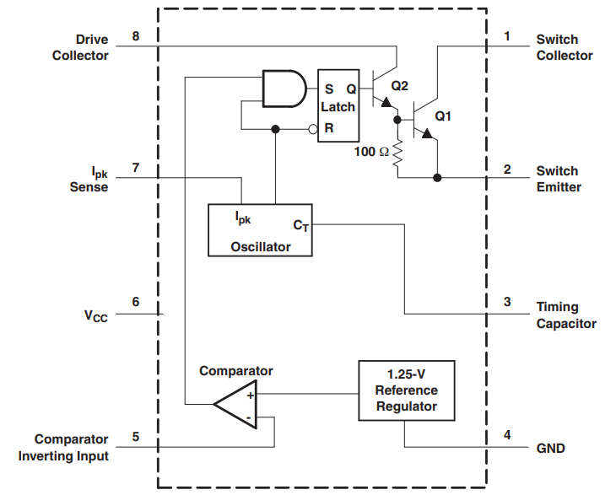

Figure ‑ Block diagram

## Reference Voltage

Output voltage

The output voltage is set by a voltage divider and compared with internal 1.25V voltage reference.

The *comparator inverting input* pin is at pin 5.

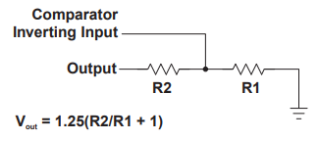

Figure ‑ How to set output voltage